User Guide
For
Service Provider
&
Supervision Center Users

Contents
1 Introduction 3
2 Service Provider 4
2.1 Apply for Login (Service Provider) 4
3 Supervision Center Users 7
3.1 Apply for Login (Supervision Center Users) 7

Introduction
This user manual is being prepared for Login . This document describes about the login process of Service Providers and Supervision Center Users.
For Service Provider Application, Go to below URL.
Web URL: https://www.sknird.com

This screen will show the CIT-101 Return link. Click on CIT-101 Return link to open it.
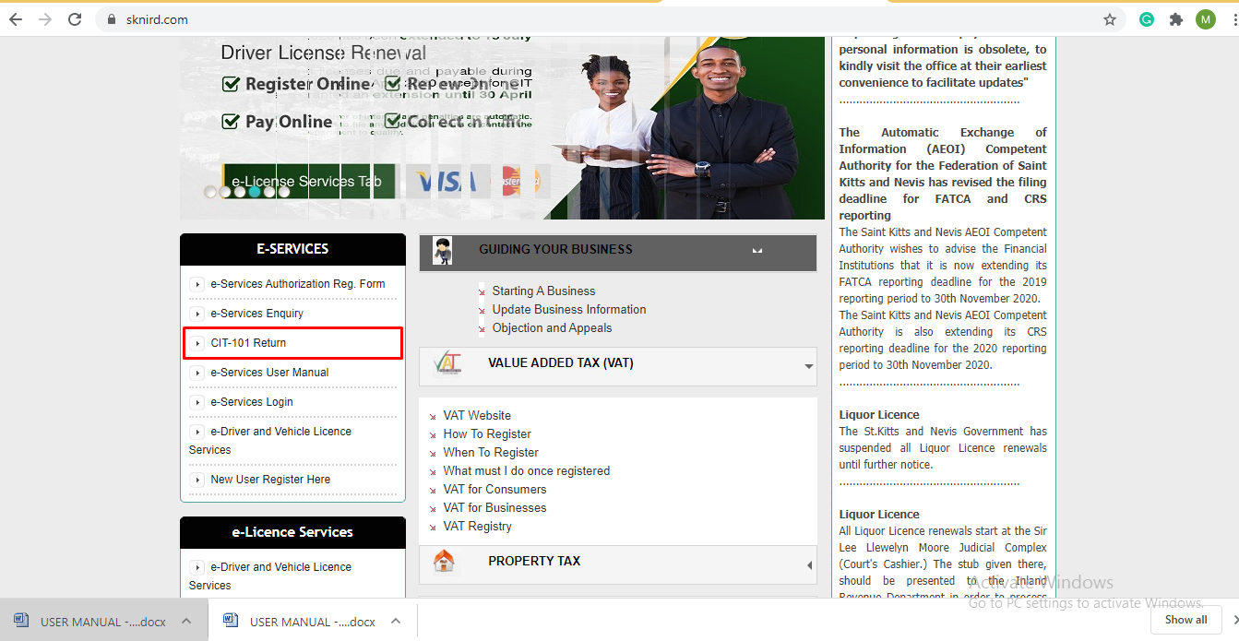

This screen shows the options for both Service Provider and Supervision Center Users.
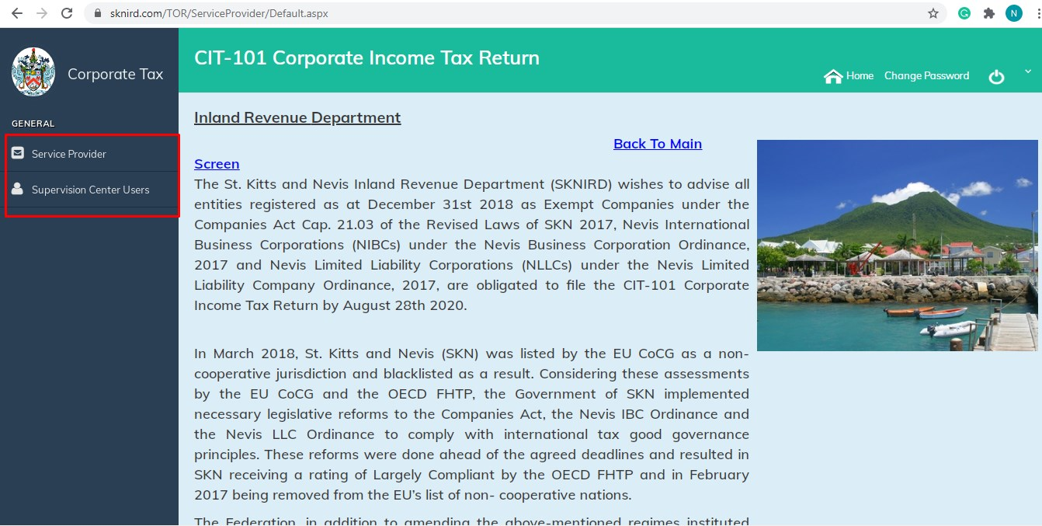

Service Provider
Service provider has to create his login account first.
For this Service Provider has to apply for login.

Apply for Login (Service Provider)
Click on Apply for Login under Service Provider.
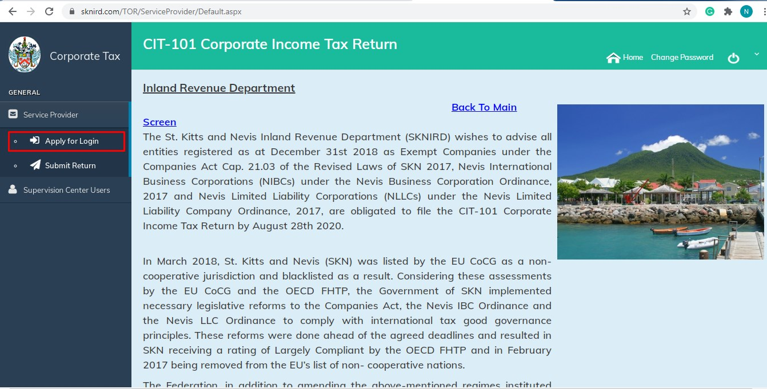

Fill the information in Service Provider Registration and click on Submit.
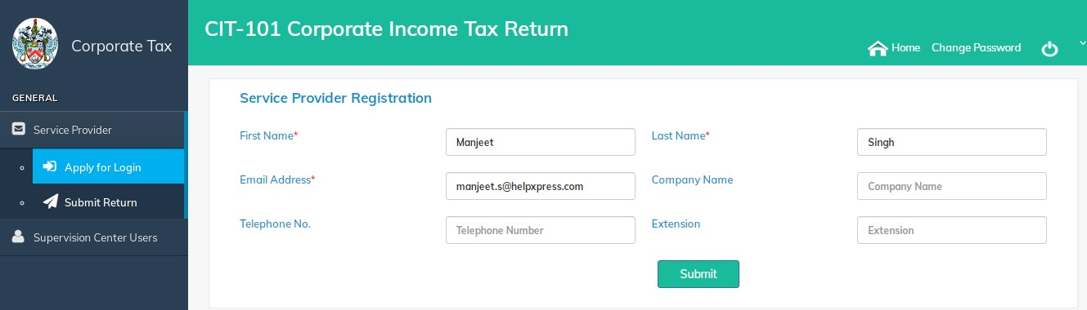

A message will show about the successfully submission of registration request.
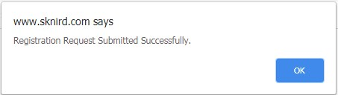

Note:
A Service Provider should be approved by Supervision Center Users.
A registered Supervision Center Users will get registration request of Service Provider for Approval/Reject.

After Supervision Center Users Approval, Service Provider will get the automatic email with approval message and login credentials.
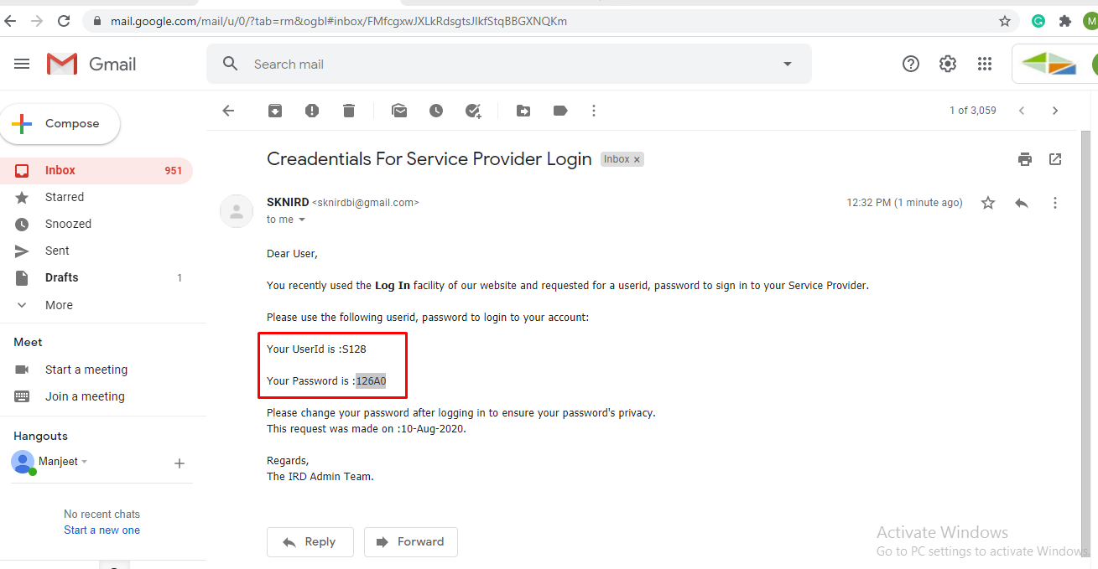

Go to home page and click on Submit Return.
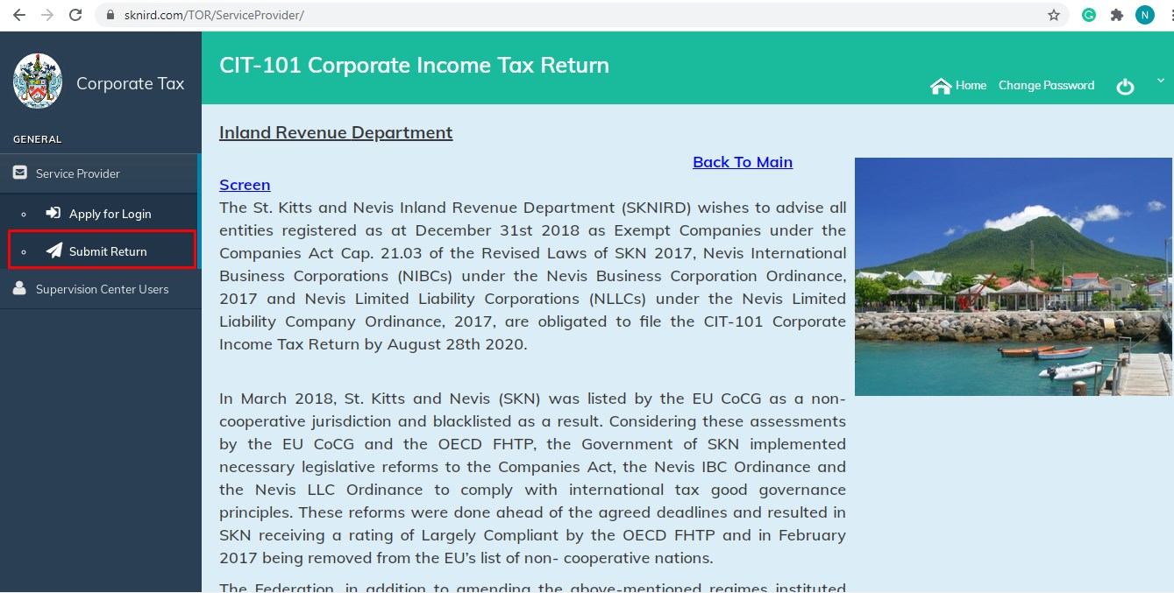

Enter the same credential that Service Provider get in email.

Service Provider will get change password screen for the first time login.

A Successful password changed message will appear.
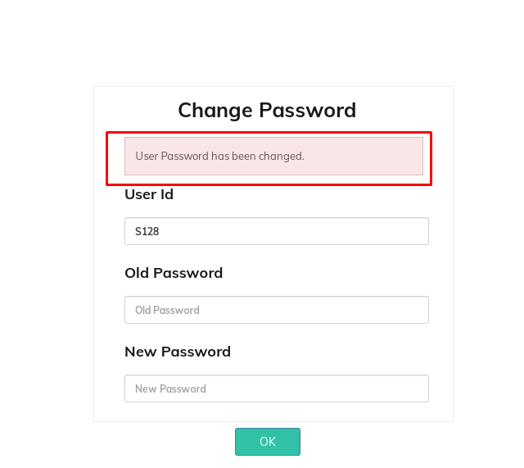

Supervision Center Users
Supervision Center Users has to create his login account first.
For this Supervision Center Users has to apply for login.

Apply for Login (Supervision Center Users)
Click on Apply for Login under Supervision Center Users.
Fill the information in Auditor Registration and click on Submit.
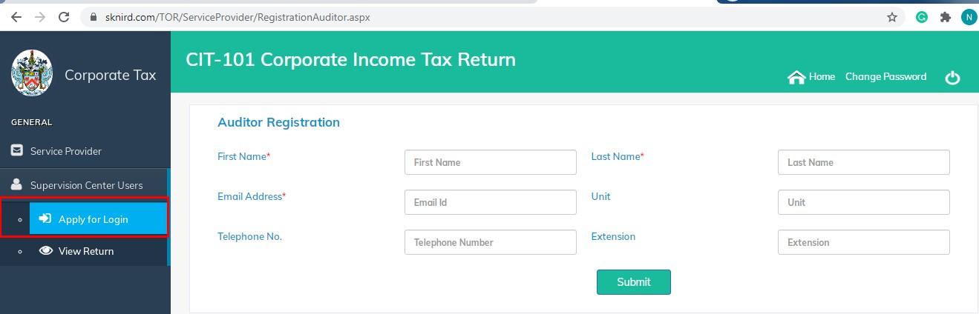

A message will show about the successfully submission of registration request.

Note:
A Supervision Center Users should be approved by registered Supervision Center Users.
A registered Supervision Center Users will get the registration request of Supervision Center Users for Approval/Reject.

After registered Supervision Center Users Approval, Supervision Center Users will get the automatic email with approval message and login credentials.

Go to home page and click on View Return.
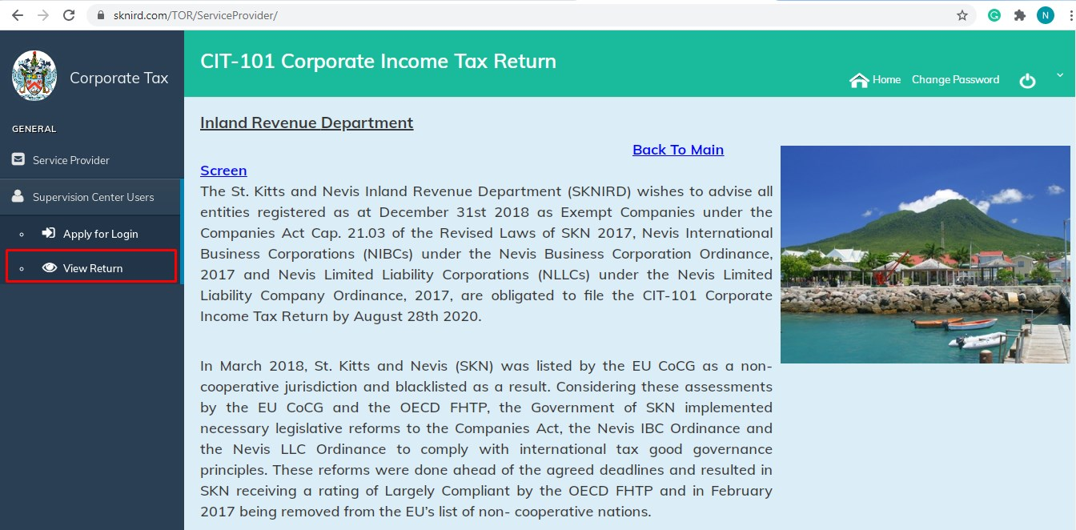

Enter the same credential that Supervision Center Users get in email.

Supervision Center Users will get change password screen for the first time login.

A successful changed password message will appear.

